Updated ~2018?

# Testbeam Muons

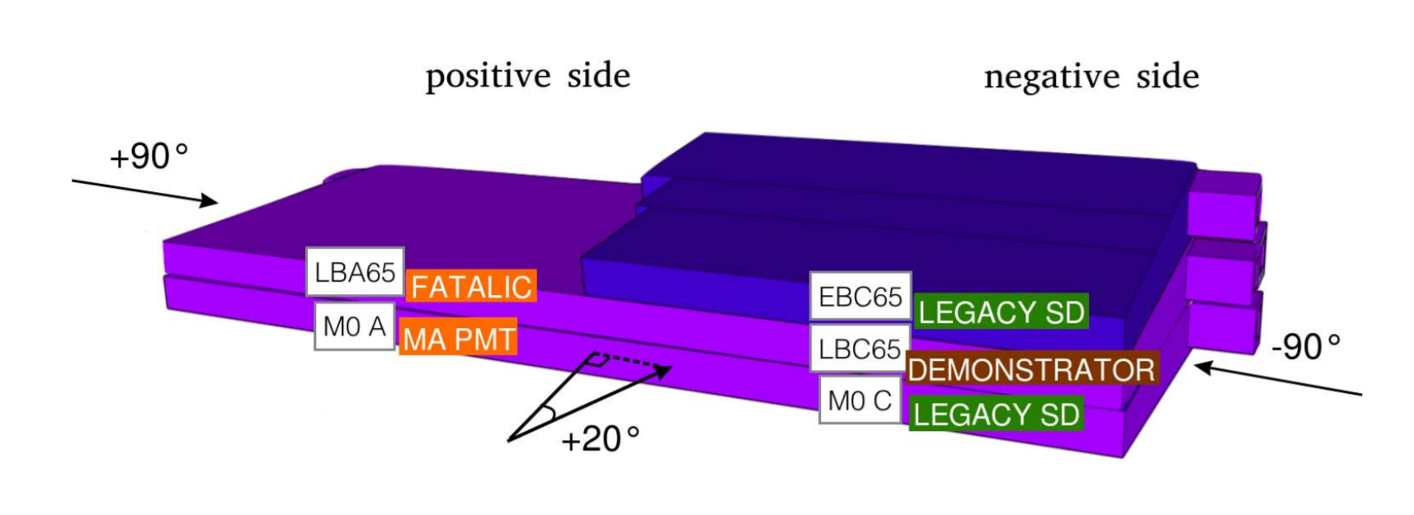

Physics of Particle Detection by Claus Grupen, Ch. 1 describes the interactions of radiation with matter. Information on the TileCal demonstrator project can be found [here](https://tilecal.web.cern.ch/tilecal/DemonstratorReview/Introduction/). Look at the [Technical Design Report](https://cds.cern.ch/record/2302628/files/ATL-COM-TILECAL-2018-003.pdf?), especially pages 42-59, for the type of analysis you may pursue. Ask Doug Schaefer or Claudio for more information or tasks.

We radiate the test beam modules with different particles like muons and then analyze their response to these particles. For muons the energy deposited through ionization shows a landau distribution, or “straggling” distribution. We want to find dE/dx, the energy deposited per unit length, in each cell of the long barrel. This is expected to be the same in every cell. The long barrel has 3 layers, of which we are most interested in the A layer (because it is closer to the beam and has the smallest cells). The presence of noise in small cells makes them more interesting.

Find the testbeam ntuples and types of runs ([Where to Find Data](https://docs.google.com/document/d/1PKoKVpdKHklOwHl3kh5ypzrvNl-KvSU3QxucgOsens4/edit#)). You can open these runs and look at the branches. The most relevant (C01 is legacy, C02 is demonstrator, etc.) are:

**EoptC02[i]:** Signal amplitude (energy) reconstructed by the Optimal Filter method, with dimension ADC counts.

**EfitC02[i]:** Signal amplitude (energy) reconstructed by the Fit method, with dimension ADC counts.

**ToptC02[i]:** Phase (time or timing) reconstructed by the Optimal Filter method, with dimension ns.

**TfitC02[i]:** Phase (time or timing) reconstructed by the Fit method, with dimension ns.

Look at the [TileCalTestbeamAnalysis2016 TWiki](https://twiki.cern.ch/twiki/bin/view/Atlas/TileCalTestbeamAnalysis2016#Description_of_the_data) (outdated) for testbeam setup and variable names, but be careful because everything has not stayed the same! Here, “i” stands for channel number. [Here is the map](http://zenis.dnp.fmph.uniba.sk/tile.html) showing the channels numbers and PMTs for each cell.

Start by playing with these variables!

**Plot the energy for cell A5:**

root -l /eos/atlas/atlascerngroupdisk/det-tile/testbeam/2017.v1/tiletb_runnumber.root

h1000->Draw(“EoptC02[19]+EoptC02[20]”)

**See which channels have a signal:**

h1000->Draw(“EoptC02:Iteration$”)

**Plot the total energy:**

h1000->Draw(" Sum$(EoptC02)")

**Note on plotting with Pyroot**

In the beginning of the program you open the data file and save it, with:

f = Tfile(“data.root”)

You should also create an output file with:

f2 =TFile(“output.root”,”RECREATE”)

Then, do whatever you need to do. In the end save the result (for example, a histogram) into the output file with:

h1.SetDirectory(f2)

f2.Write()

f2.Close()